Current situation (pic1)

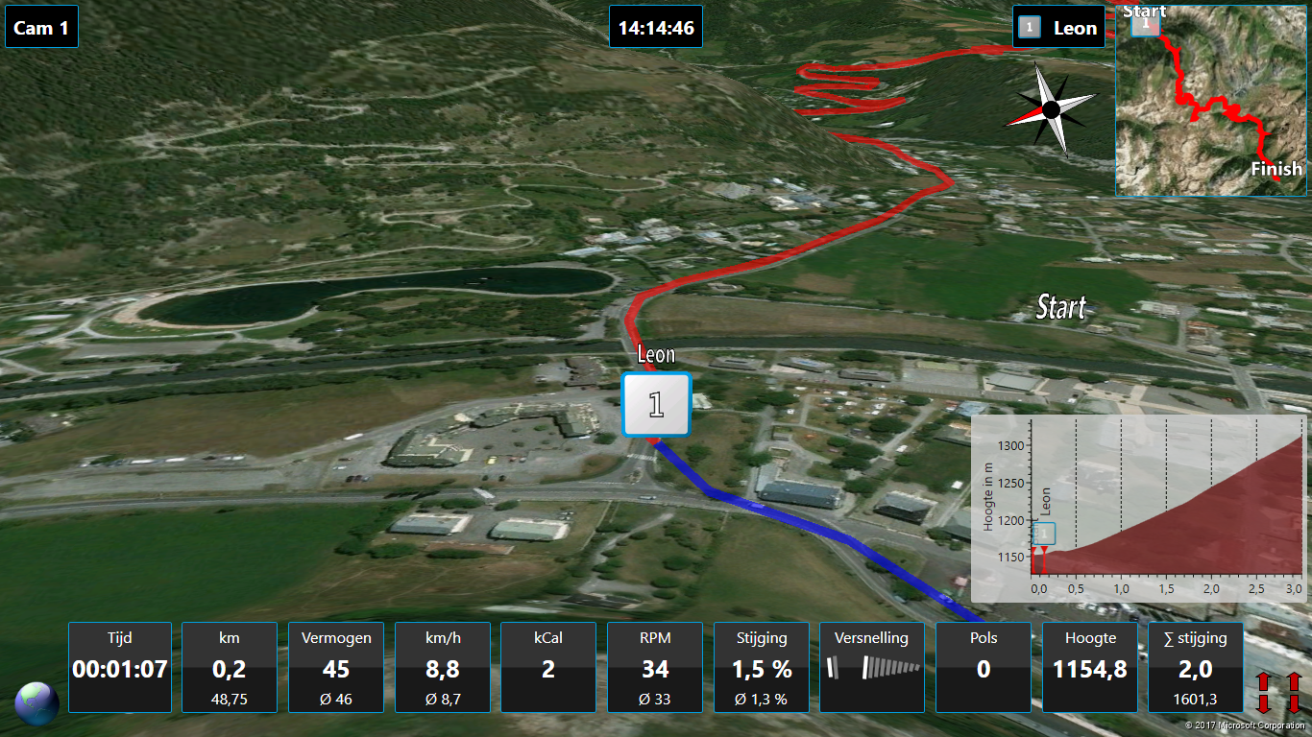

What i want (pic2)

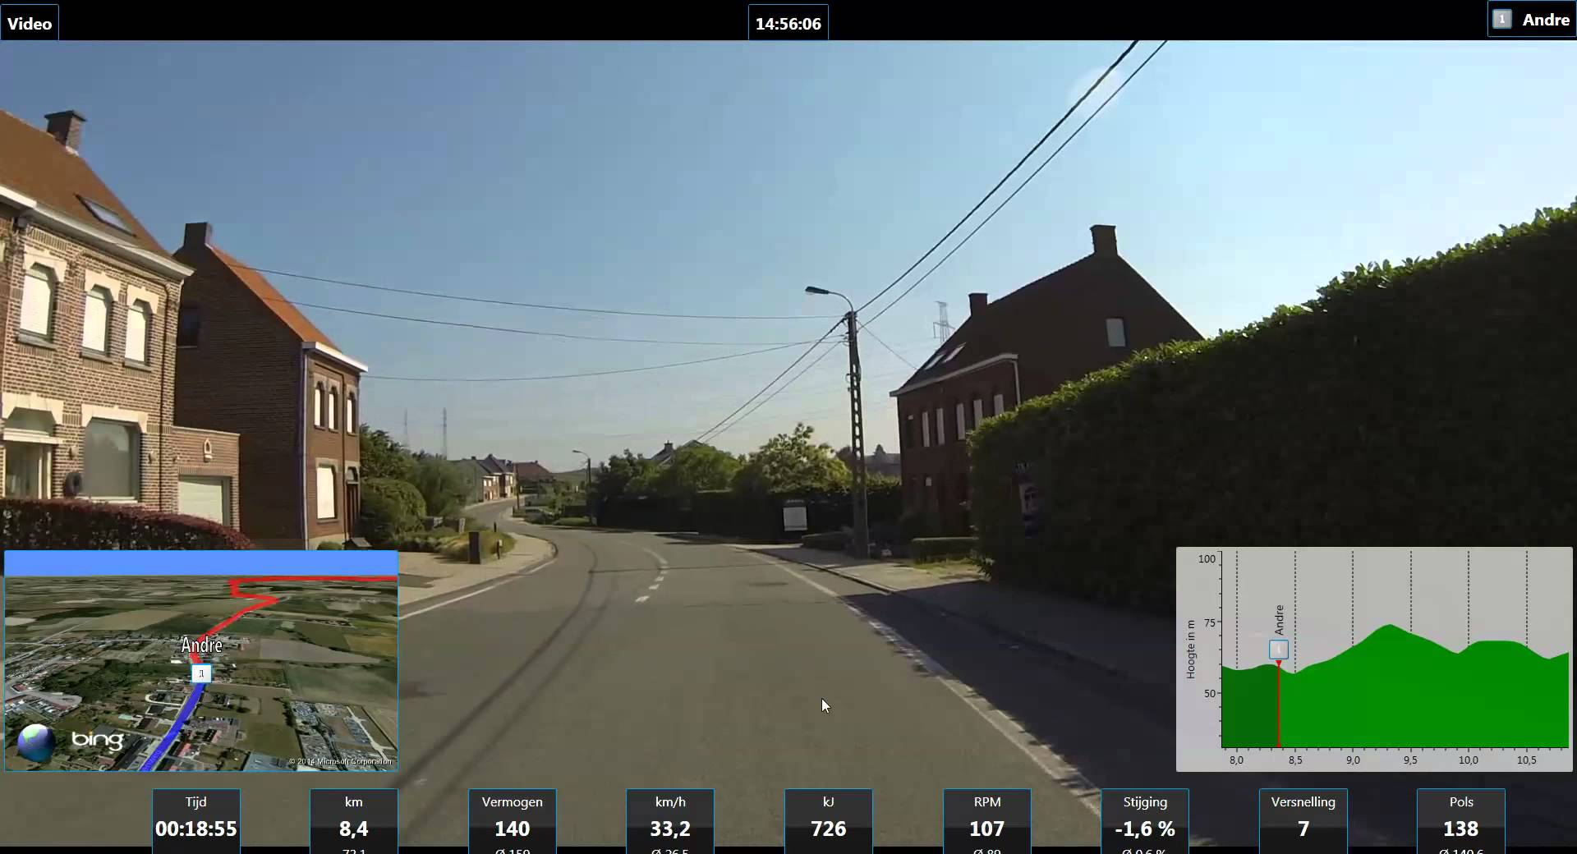

How do i get the view of pic2, the 3d video-image instead of cam 1

